

המחלקה להנדסת חשמל ואלקטרוניקה

מערכות לומדות ולמידה עמוקה (31245)

Lab 10 report

פרנסיס עבוד

Prepared for: Dr. Amer Adler

Date: 27/06/2025

Deep Learning – Lab – Sentiment Analysis

1. Load the MLP-based and 1D-CNN-based IMDB Sentiment Analysis solutions into Colab.

2. Train and compute the test data accuracy. Plot the loss and accuracy training curves.

3. Add early stopping to find the optimal stopping point. Is there any improvement compared to the baseline accuracy?

4. In the CNN network, change the embedding layer dimension to a few different values, re-train and compute the test data accuracy. Which value provides the best accuracy?

5. Repeat step 4, for the MLP network.

6. In the CNN network, remove 1 convolutional layer, and compute accuracy, afterwards remove 2 layers. Try also to change the kernel length. What is the impact on the accuracy?

7. In the MLP network, increase the FC layer to a higher number of neurons, and compute accuracy. Which value provides the best accuracy?

Solution:

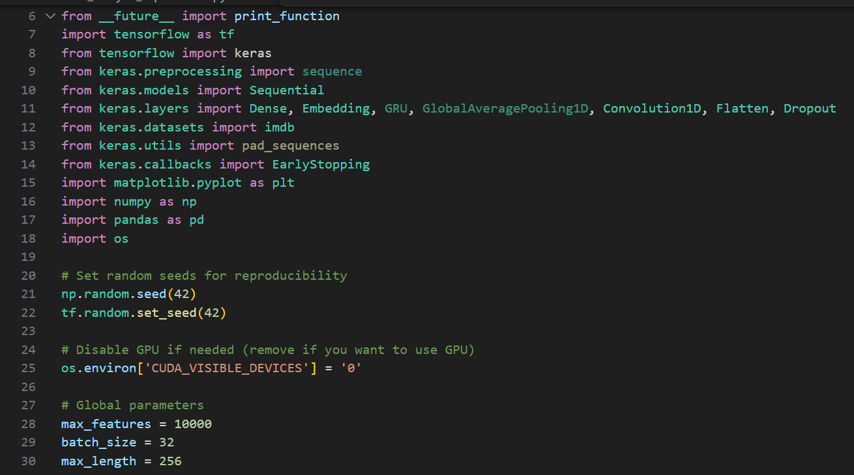
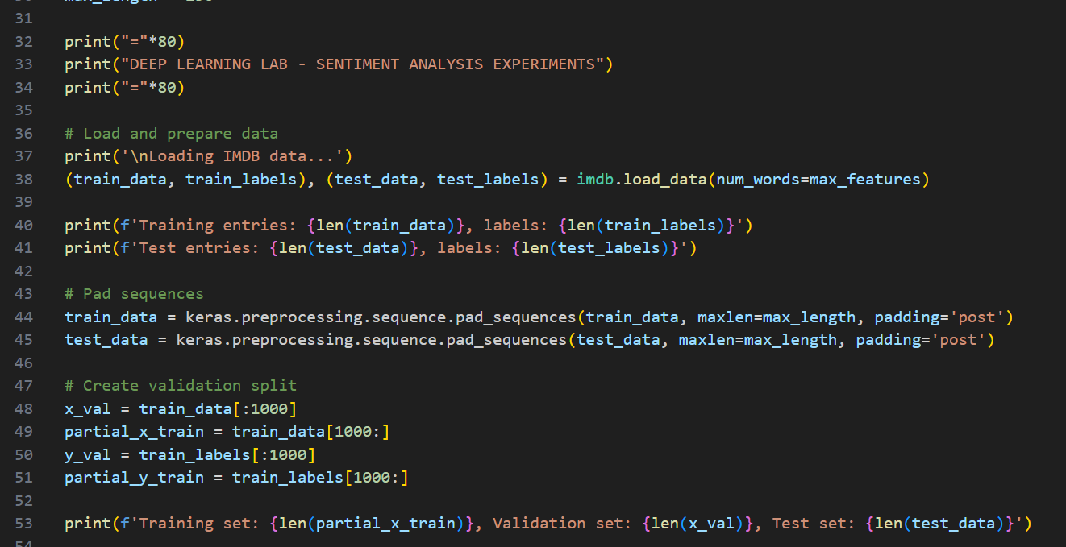

- Load the MLP-based and 1D-CNN-based IMDB Sentiment Analysis solutions into Colab:

Code:

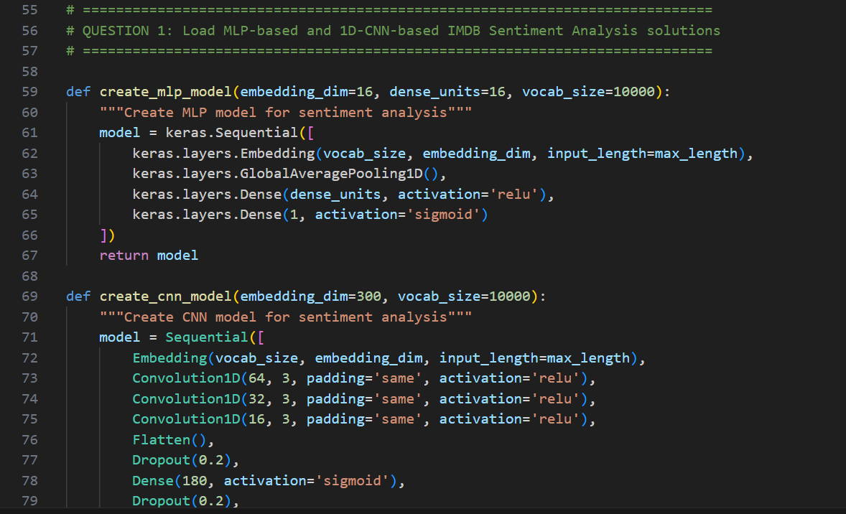

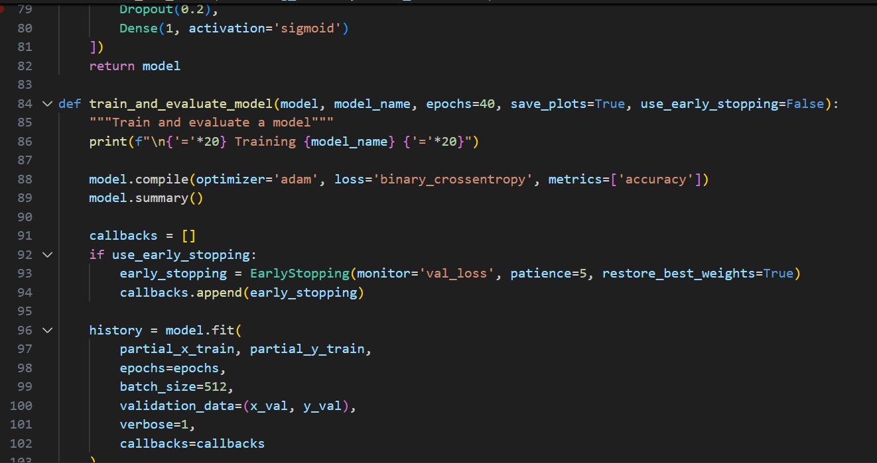
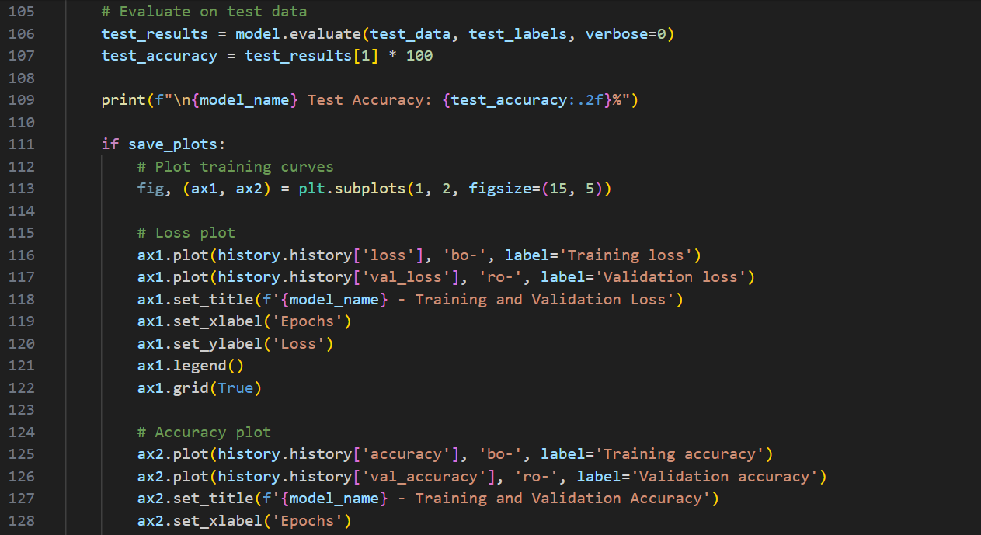

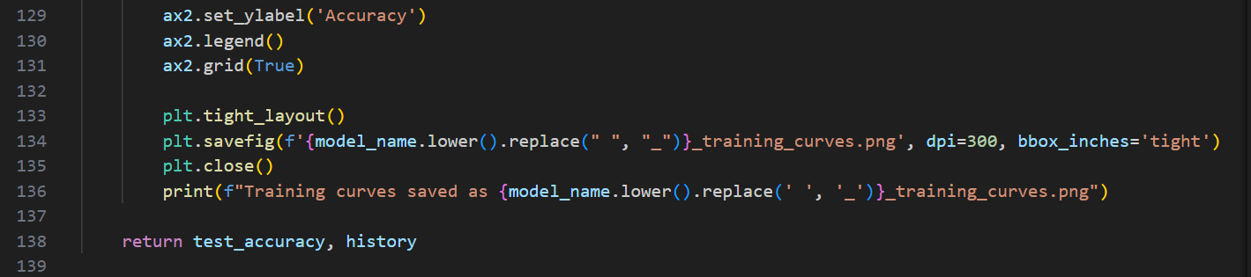

2. Train and compute the test data accuracy. Plot the loss and accuracy training curves.

Code:

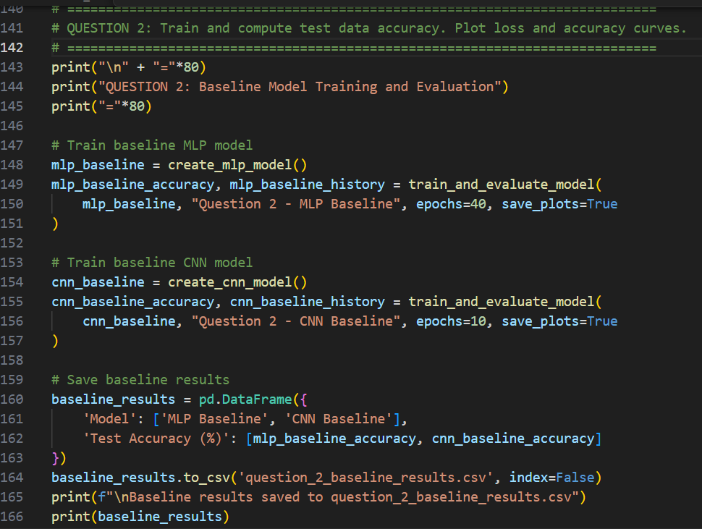
Output for Q-2:

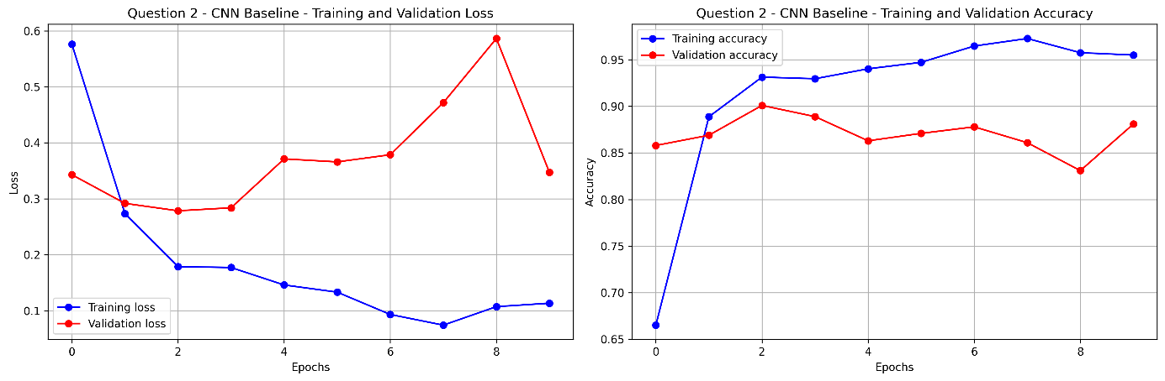

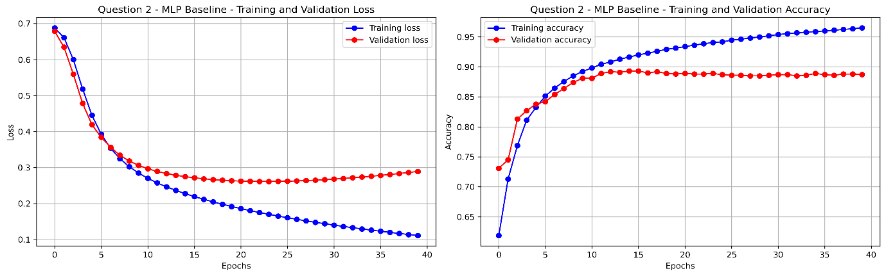

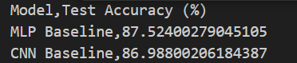

3. Add early stopping to find the optimal stopping point. Is there any improvement compared to the baseline accuracy?

Code:

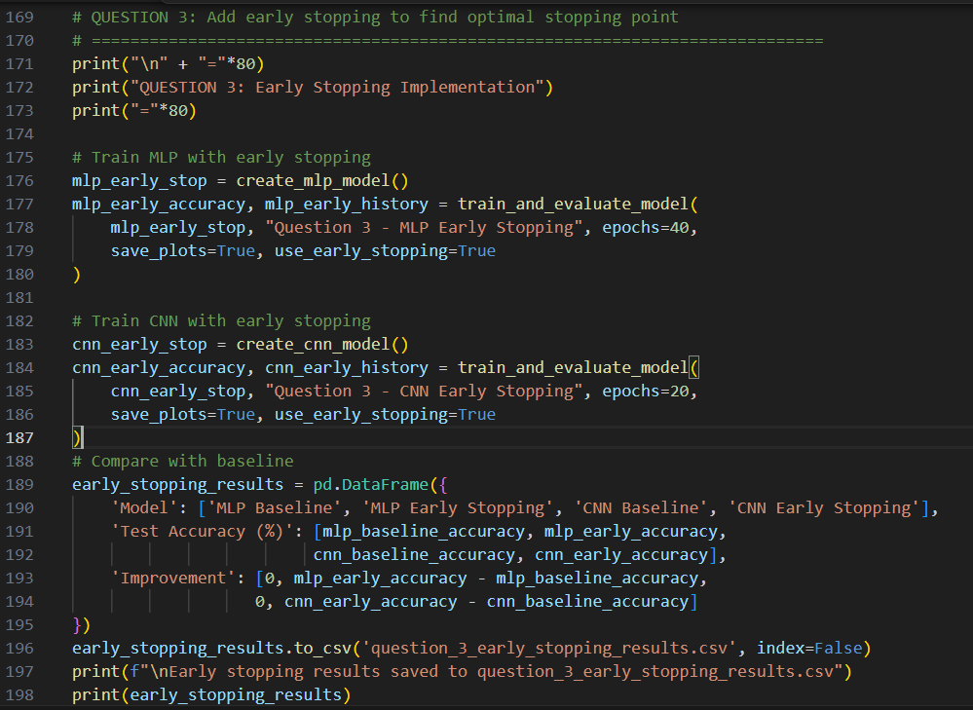

Output for Q-3:

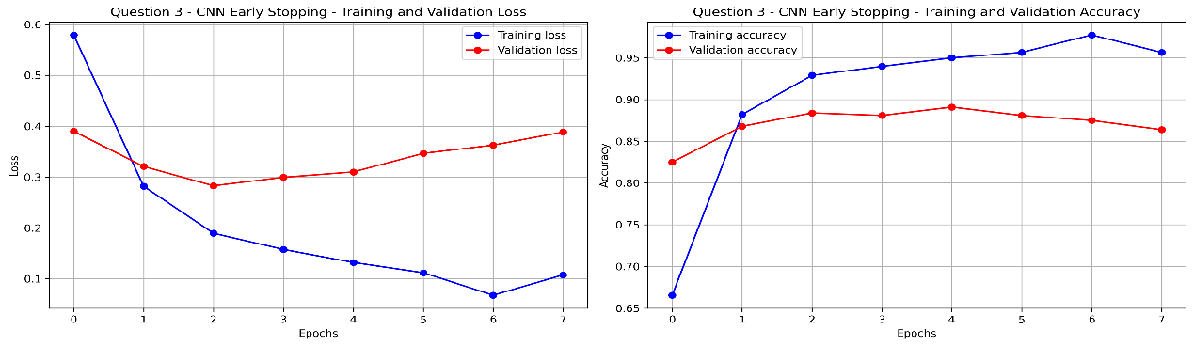

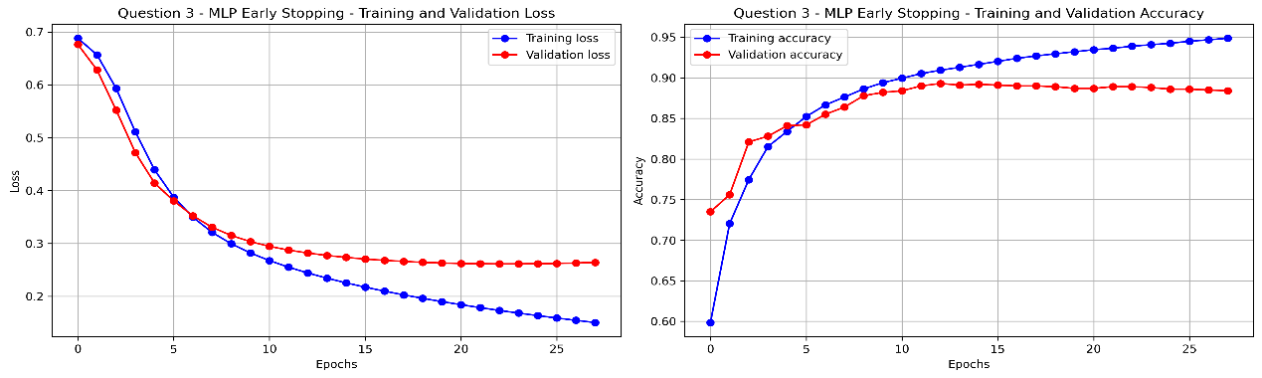

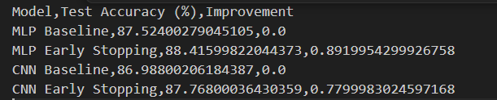

4. In the CNN network, change the embedding layer dimension to a few different values, re-train and compute the test data accuracy. Which value provides the best accuracy?

Code:

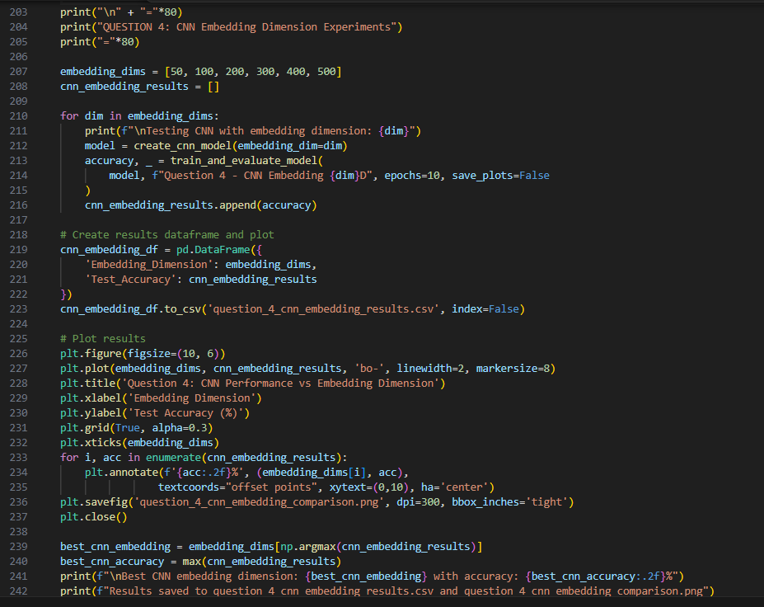

Output for Q-4:

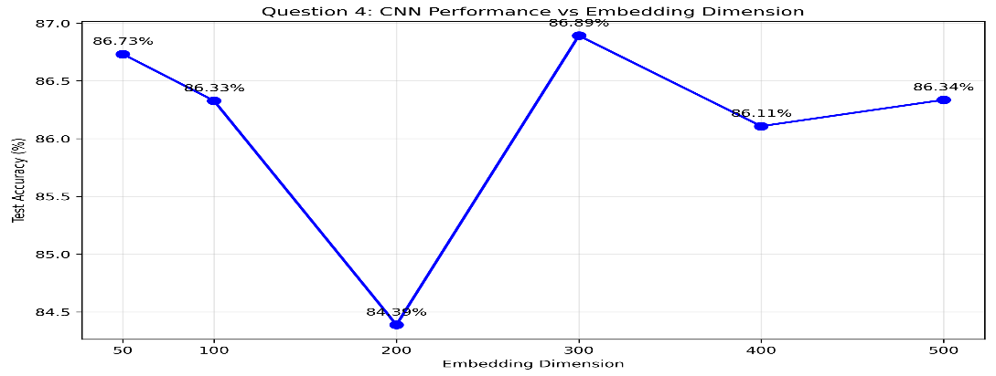
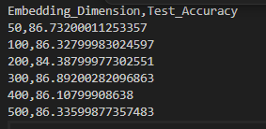
5. Repeat step 4, for the MLP network.

Code:

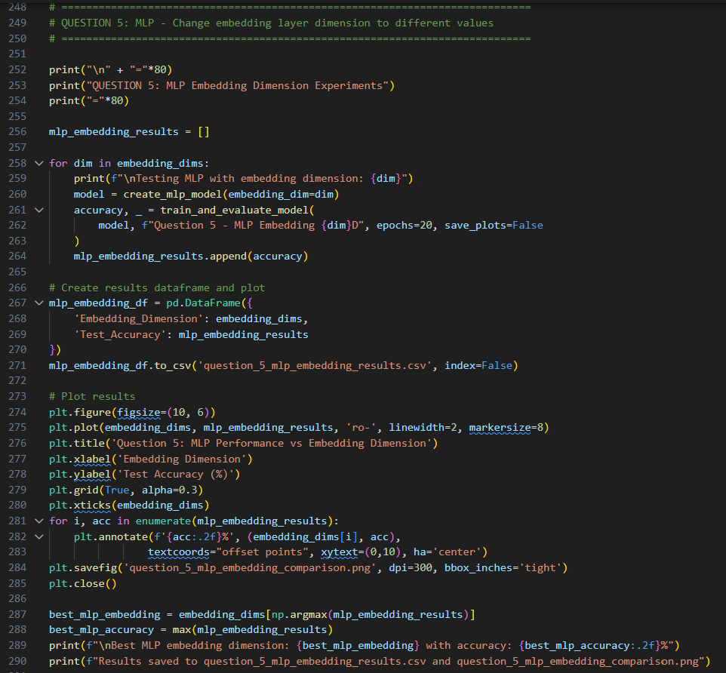

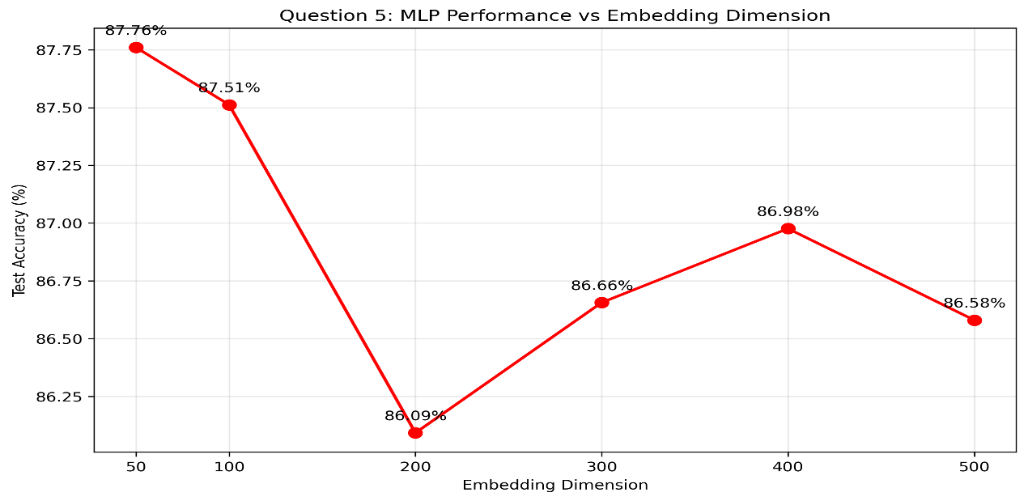
Output for Q-5:
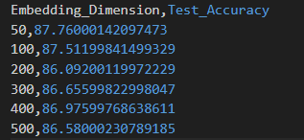
6. In the CNN network, remove 1 convolutional layer, and compute accuracy, afterwards remove 2 layers. Try also to change the kernel length. What is the impact on the accuracy?

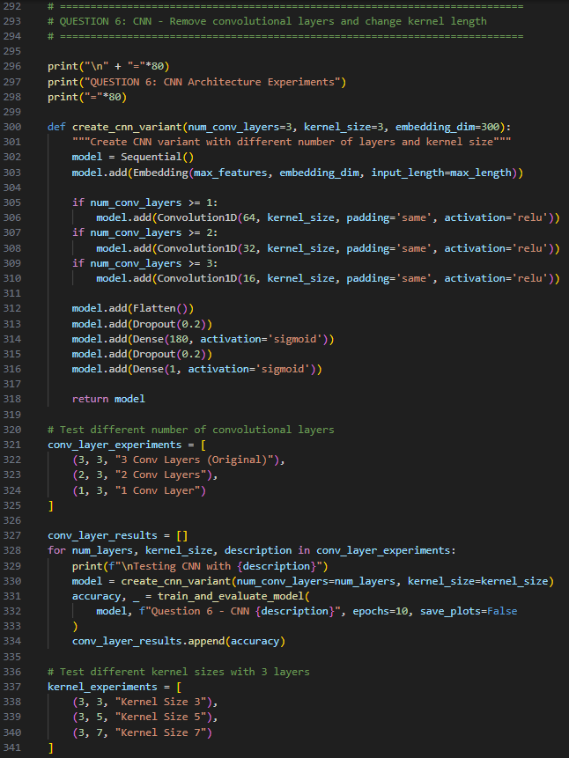
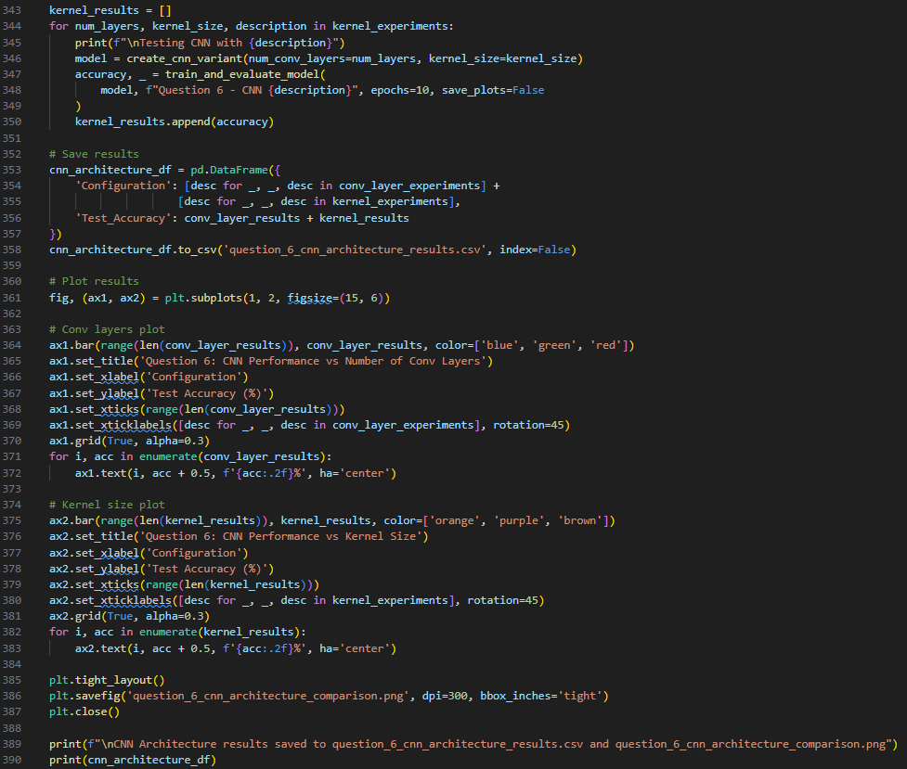
Code:

Output for Q-6:

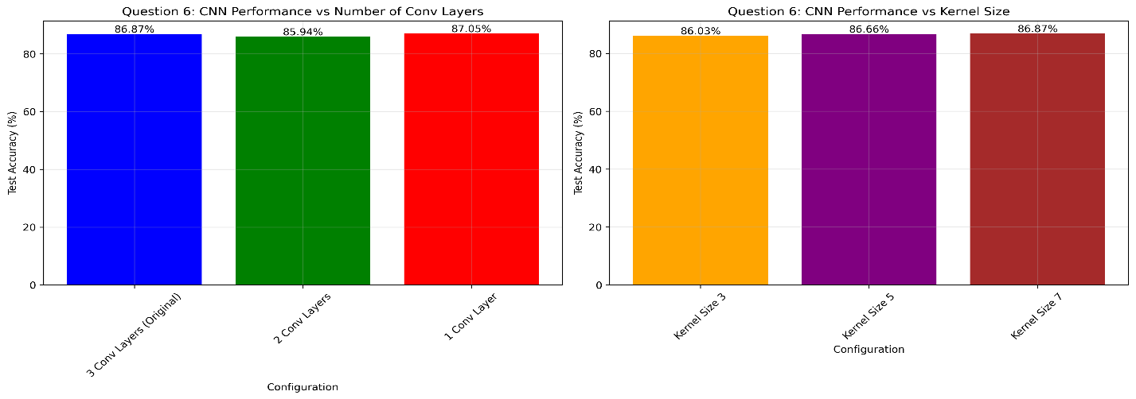

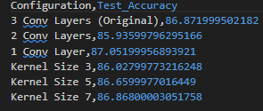
7. In the MLP network, increase the FC layer to a higher number of neurons, and compute accuracy. Which value provides the best accuracy?

Code:

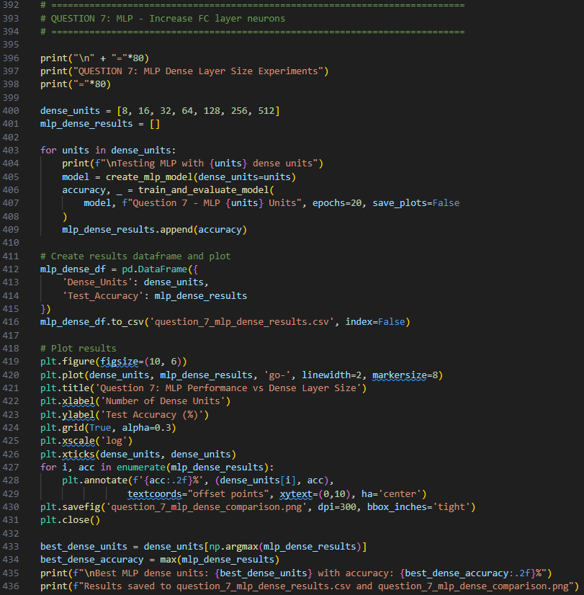

Output for Q-7:

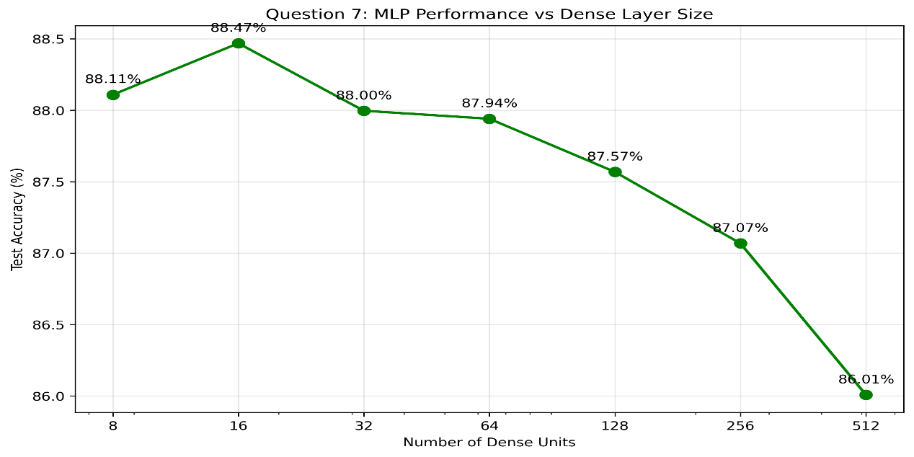
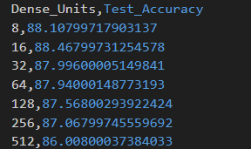
SUMMARY OF ALL EXPERIMENTS

